**Testing Document**

**File structure:**

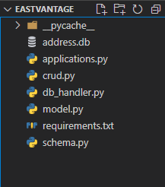

**To run the program:** Run the command uvicorn applications:app --reload in command prompt

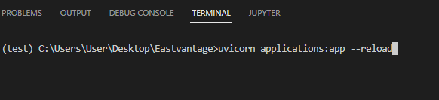

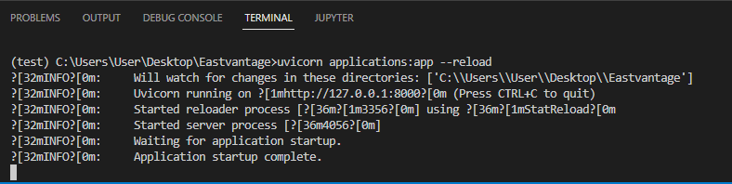

**Open the URL in browser:** <http://127.0.0.1:8000/docs>

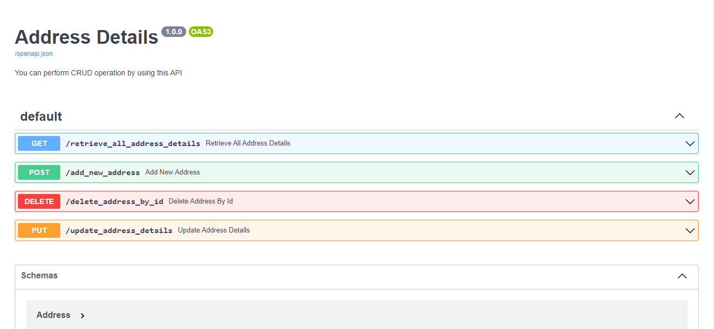

**Test 1:** Fetch the records from database

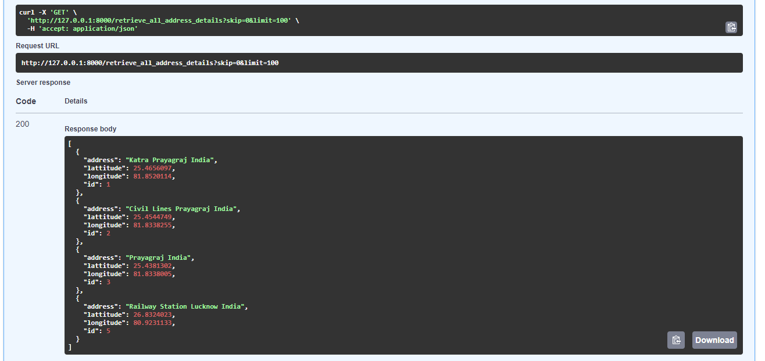

**Test 2:** Add the record in Database

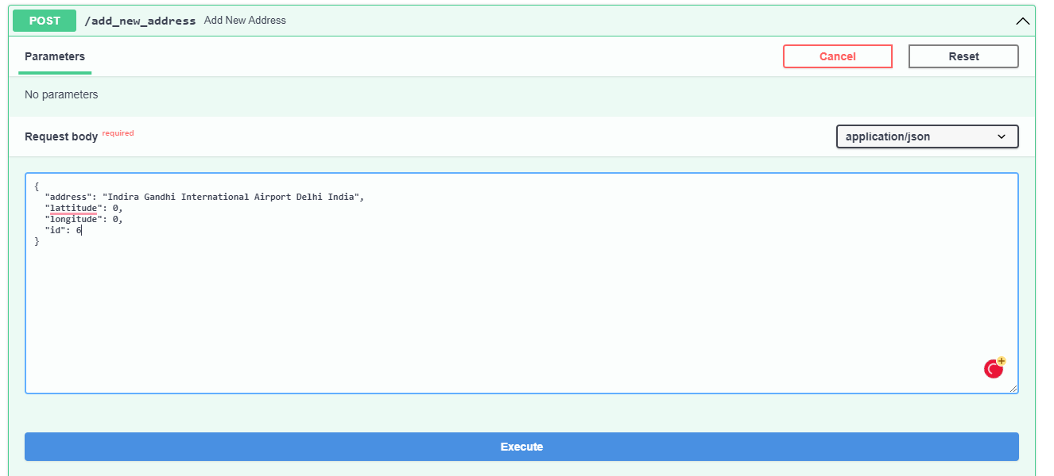

Response

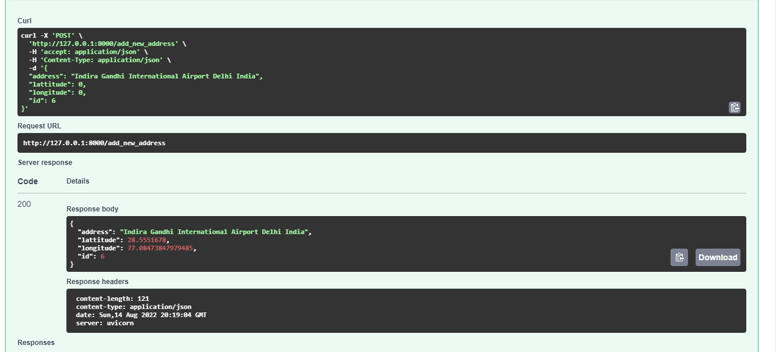

**Test 3:** Update the existing data

Currently ID - 5 has below data in database

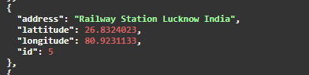

We will change the Address from ‘Railway Station Lucknow India’ to ‘Railway Station Bangalore India’ and its corresponding latitude and longitude will change automatically

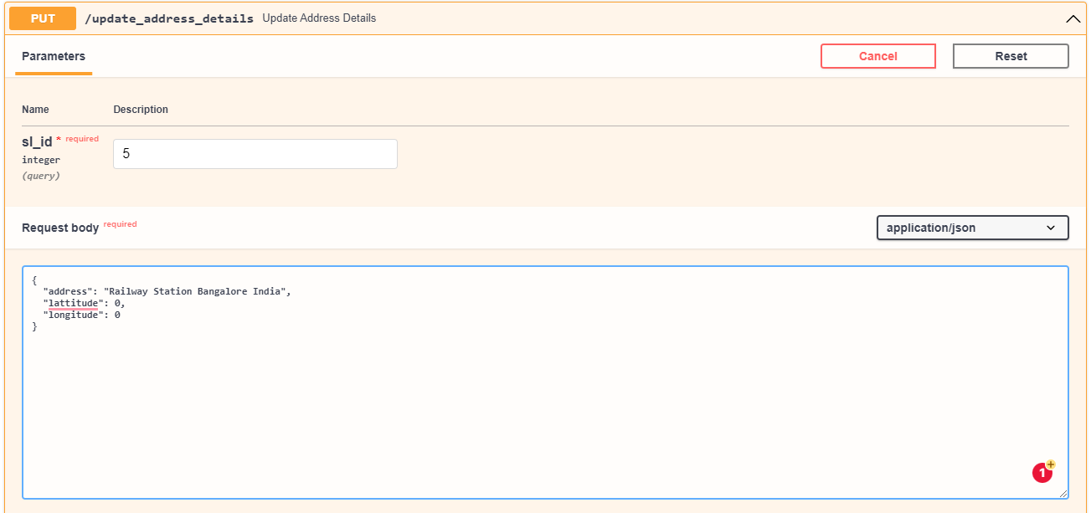

Response

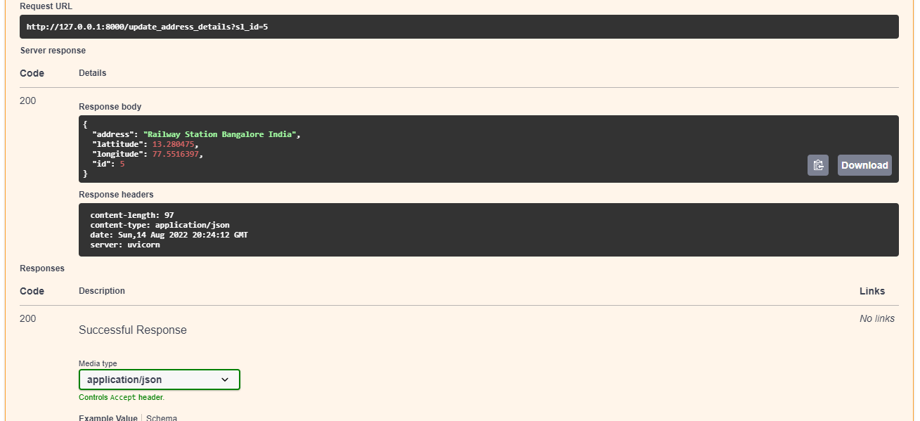

**Test 4:** Delete data record from database

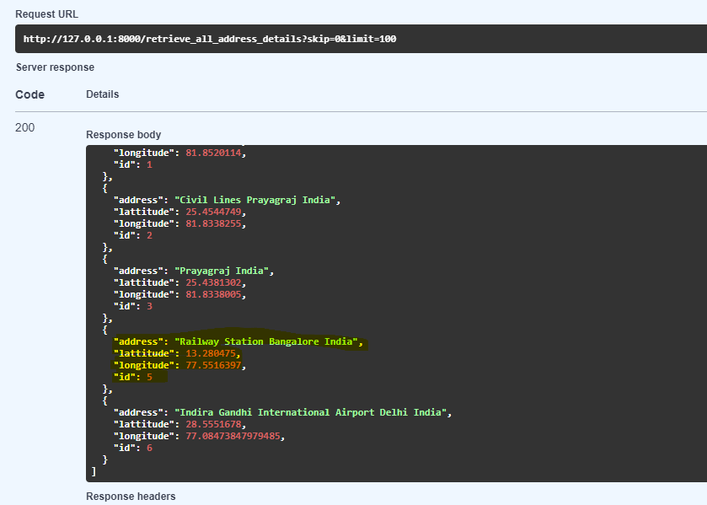

Delete data record with ID – 3

